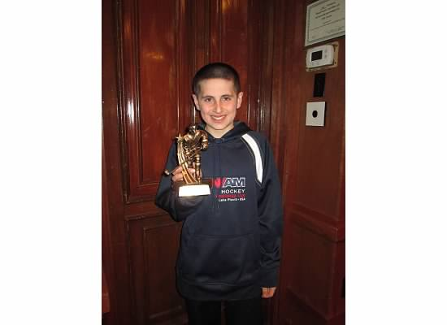Jake’s Profile

Jake Lorah is going to PCTI taking Computer Science as his shop class. He learned a lot about html and coding from his great teacher Mr. Mix. Coming back from winter break, Jake decided to create a website from scratch from all of the stuff he learned this year. He went through many problems in the website but his friend Joey, also in Computer Science, fixed them for me. After cleaning up the site and fixing the errors, he finally finished the website. Now Jake will edit the website monthly and he will keep adding new things to it as he learns more and more.